BigQuery API

A data platform for customers to create, manage, share and query data. By using bigquery API’s we can help to manage Data warehouse resources, machine learning models and execution resources. The following discussion shows the details about BigQuery API’s.

1. Data warehouse resources

* Datasets
* Tables(including externals and views)
* Routines

1. BigQuery machine learning

* Models

1. Execution resources

* Jobs

**When to use BigQuery API’s?**

* Programmatically get query results using your business data using BigQuery
* Add new data to your existing table
* Analyse data from databases

Coming to **connection API and storage API** of BigQuery.

BigQuery connection API allows us to programmatically create and manage connections which is helpful when we have multiple databases whereas storage API in BigQuery has two components as

Storage API

* READ client(to read large volumes of data)
  + Parallelize reads
  + Perform partial projections
  + Filtering data
  + Precise control over snapshots
* WRITE client
  + Advanced patterns for streaming

Data transfer service(DTS) API (automate work to ingest data from known sources like Cloud storage, Google marketing platform, you Tube and other third party resources).

Reservation API

* Purchase slot commitments
* Add or remove slots from reservations
* Manage reservation assignments

Data QnA API

To get answers about analytical queries through natural language processing questions. With the help of QnA API we can convert natural language texts in queries into SQL statements.

**Data governance**

* DLP(cloud data prevention)
  + To protect your sensitive data
* Data sharing

**BigQuery storage API**

**Bucket location**

* Select your project
* Enable **google cloud storage service**
* Use google cloud storage service (click on Navigation menu)
* Click in API and resources and then go to library
* Search for Cloud storage
  + There are two services.
    - Google cloud storage JSON API
    - Cloud storage

**Points to note**

* Create credentials
* Install Google cloud storage python SDK
* Create new Bucket

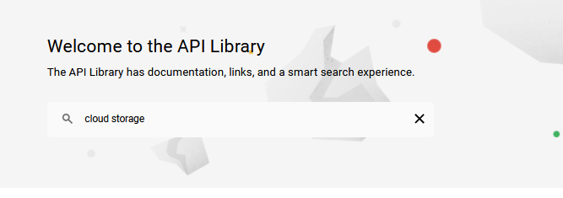

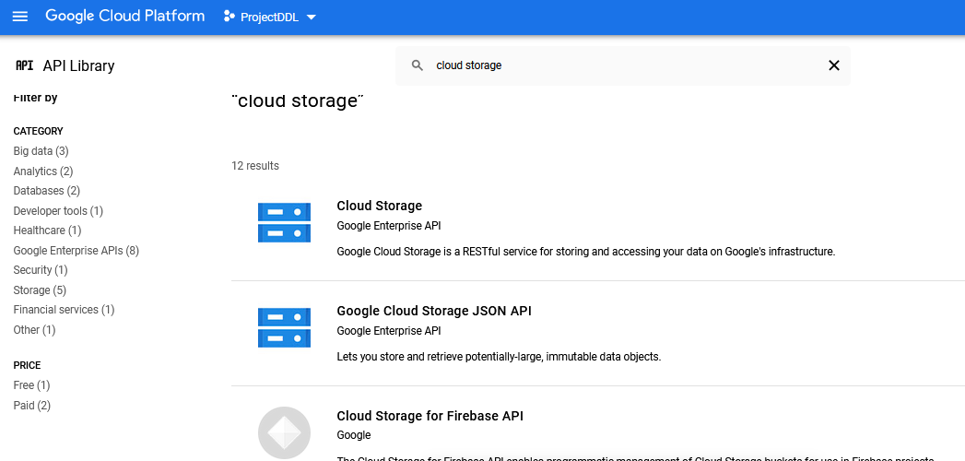

* GO TO Google cloud storage JSON API and make sure this service is enabled.

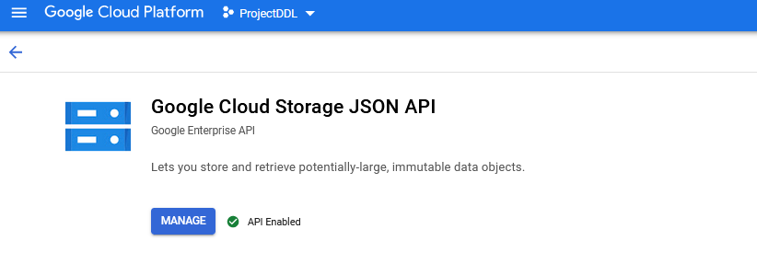

**How to create a service account?**

* Go to API and services and click on credentials.

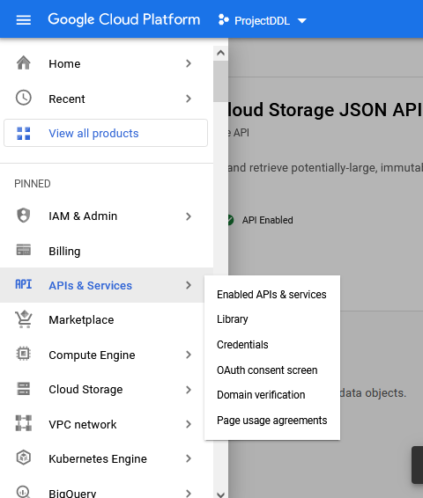

Then the result comes as….

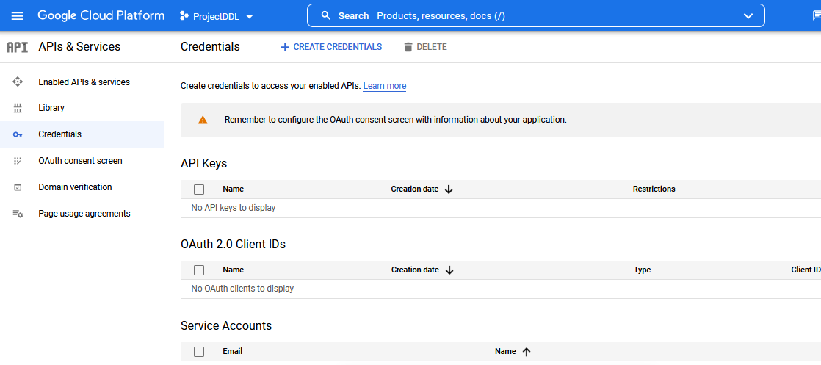

We will get all the service accounts if not we can create a service account as below…

* Click on create service account

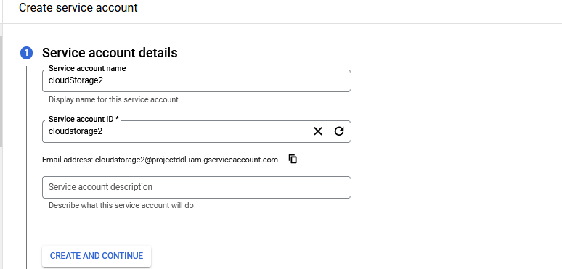

* Click on create and continue.
* Choose Basic …owner
* CONTINUE

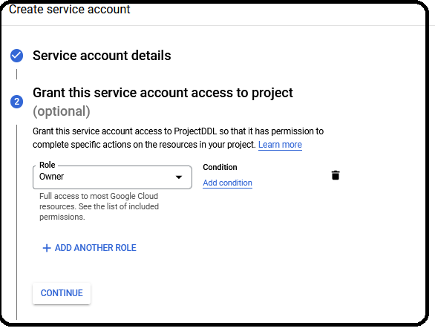

* Skip the next option and then check your service account has been created.
* Click on the service account file and download the file in json format.

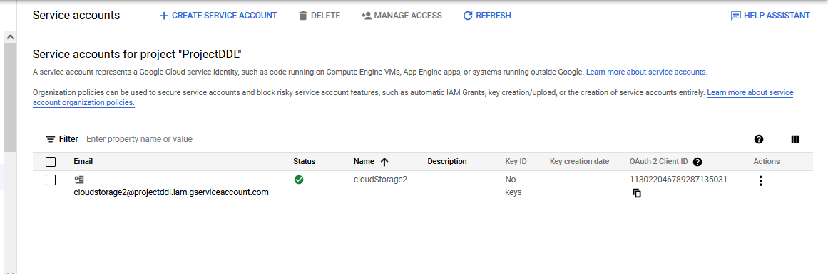

* Go to keys and click on ADD KEY.
* From the key type choose JSON and CREATE.

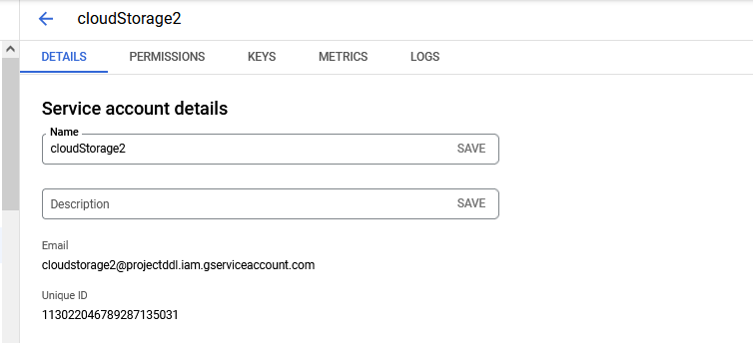

THEN…

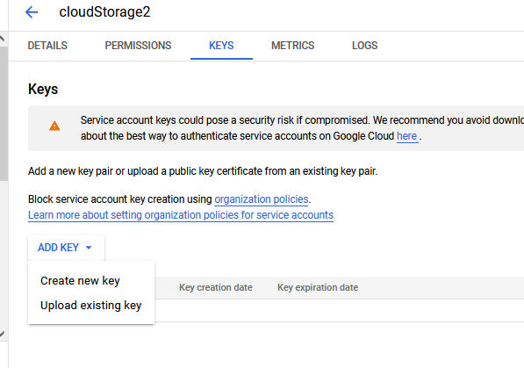

* Click on CREATE NEW KEY.

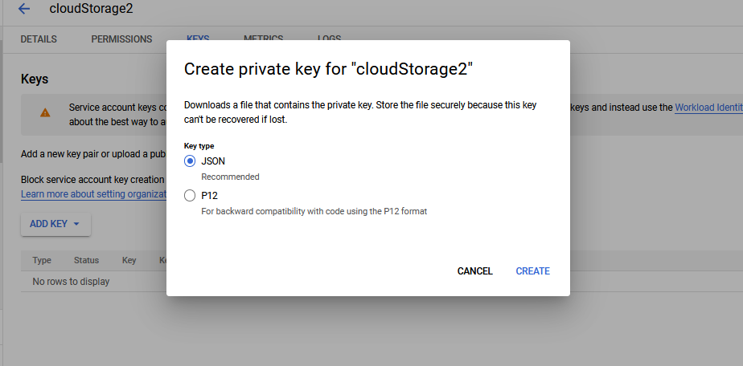

THEN we will get a message as

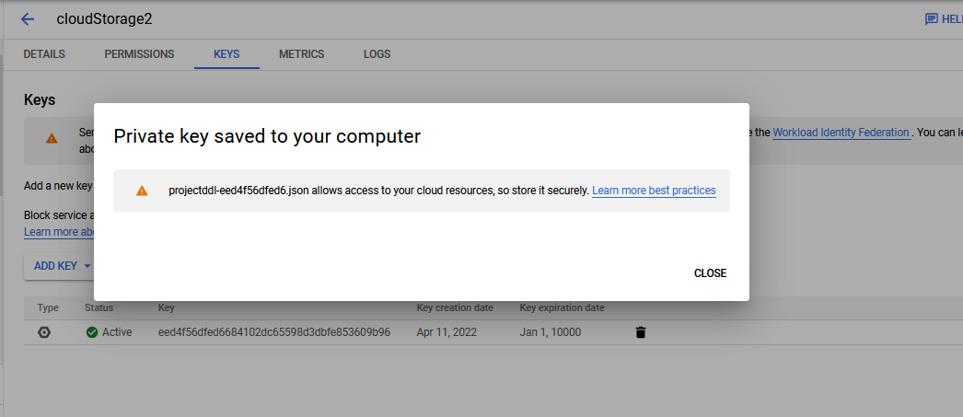

* A service account file will be created and stored in your download folder. W e can move it to our on directory.
* Name it as service\_key\_GoogleCloud.
* Download GCloud SDK package.

**I have a GCP account. Want to** **connect this account** from my local **Windows system**.

https://www.edureka.co/community/82162/how-to-install-the-google-cloud-sdk-in-windows-system

**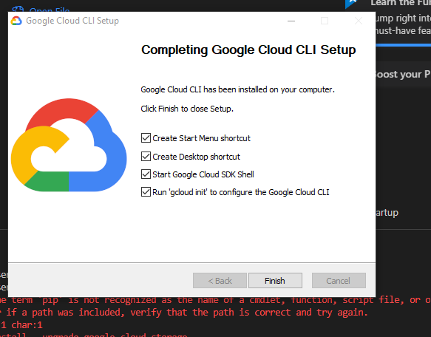**

**Run 'gcloud init'**

* The installer then starts a terminal window and runs the [gcloud init](https://cloud.google.com/sdk/gcloud/reference/init" \t "_blank) command.

**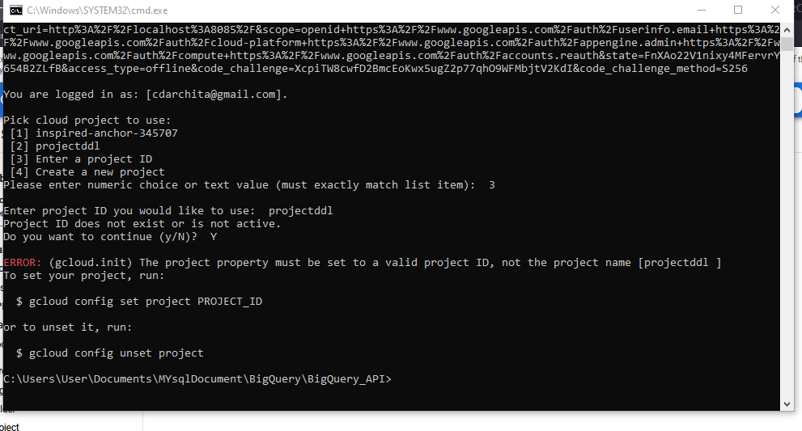**

**Create New Bucket**

**Go to Google Cloud Storage….click on BROWSE….. create a bucket<bucket name>**

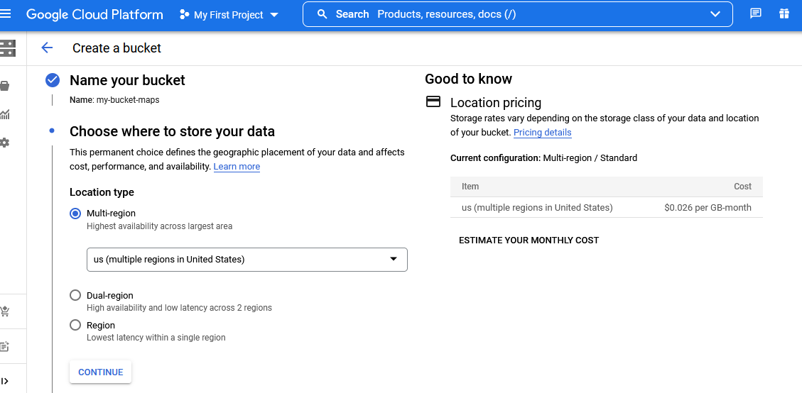

**my-bucket-maps**

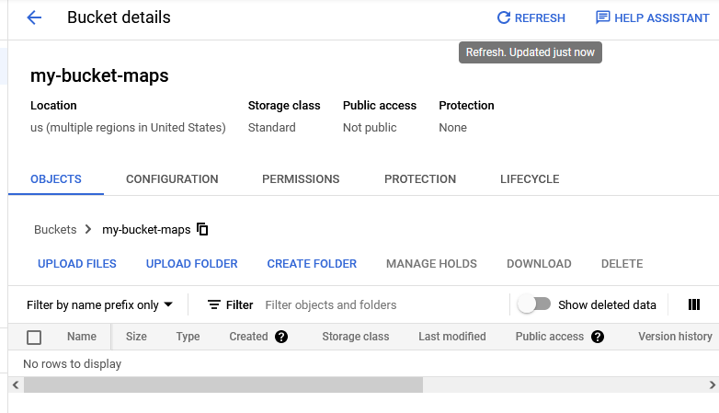

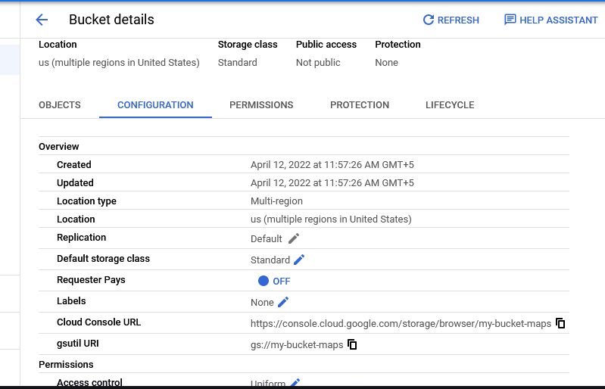

**Go to Google Cloud Storage…select storage….**

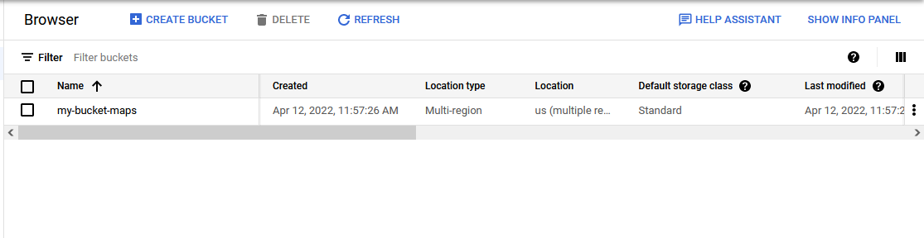

<https://console.cloud.google.com/storage/browser/my-bucket-maps>

chinugcp@inspired-anchor-345707.iam.gserviceaccount.com

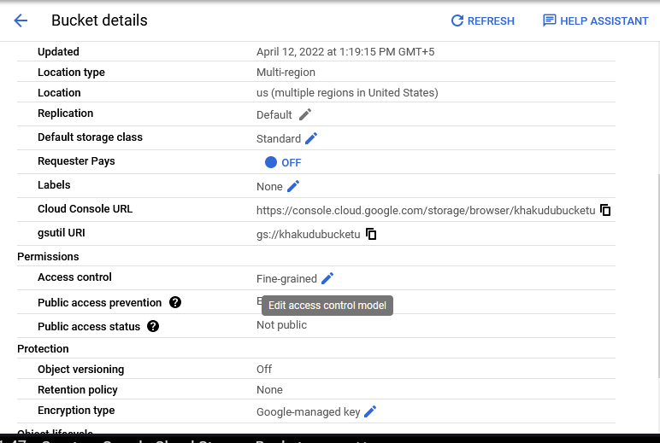

**Create a service account**

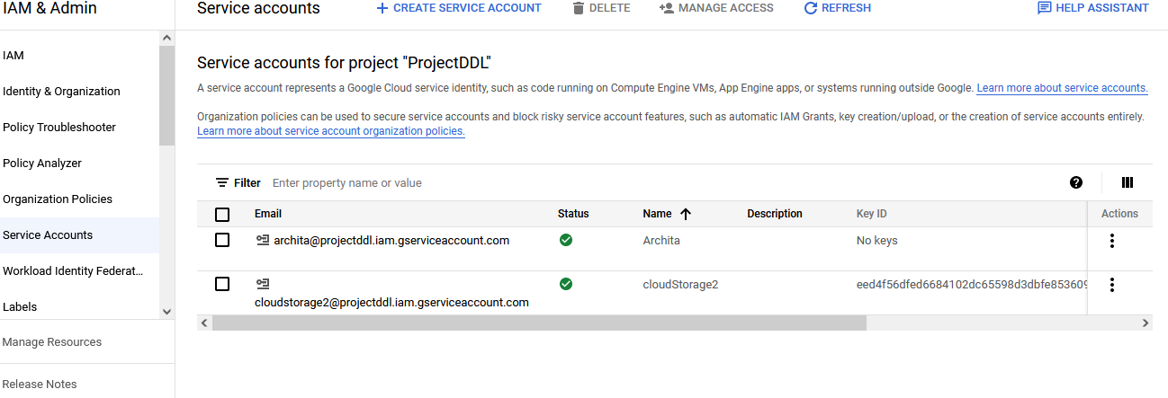

**Create a KEY**

**CLICK on your service account id**

**GO TO Keys**

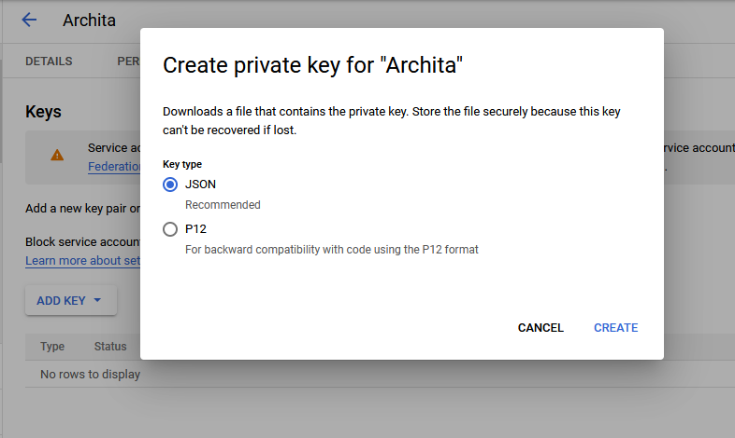

projectddl-67342a414eac.json

**Steps needed to store files in a Bucket**

[BucketStorage\_pythonCode.docxBucketStorage\_pythonCode.docx](BucketStorage_pythonCode.docx)

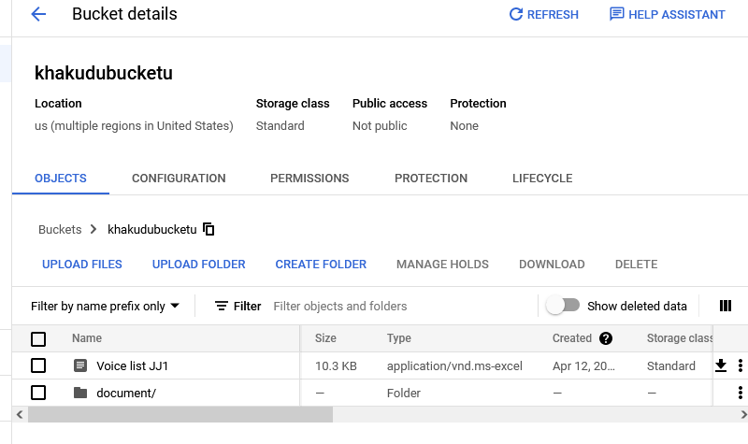

**Go to document/ folder …we can check the VoicelistJJ1 file under Document folder.**

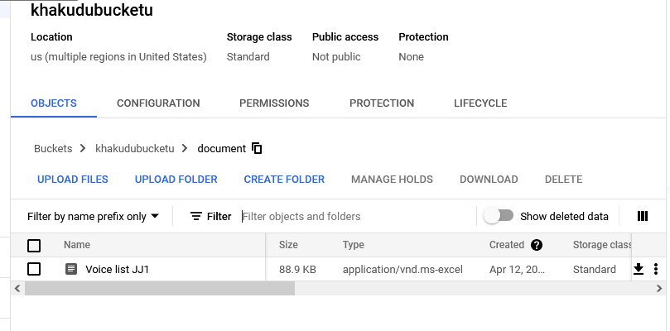

**Download files from Document folder.**

